Mr. Jackson Price, President
Price & Price Company
100 Hess Boulevard, Suite 3532
Austin, TX 78712-2196

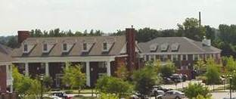
Hess Office Park
100 Hess Boulevard, Austin, TX 78712-2149
Phone 512.555.0157 | Fax 512.555.0158
www.hesspropertyenterprises.com

November 20, 2018

Mr. Jackson Price, President
Price & Price Company
100 Hess Boulevard, Suite 3532
Austin, TX 78712-2196
Dear Mr. Price
We are pleased to welcome you as a new tenant in the Hess Office Park and invite you to the Owners and Tenants Association December meeting on Tuesday, December 2, at the offices of Schniepp Enterprises. The meeting begins at 6:30 p.m. with snacks and drinks provided by our host and offers a casual environment for meeting other owners and tenants.
The Owners and Tenants Association meets regularly on the first Monday of each month at 6:30 p.m. at the location of one of the owners and tenants. However, the December meeting was moved to Tuesday evening to accommodate the many businesses involved with the local Christmas parade. The January meeting will return to Monday evening and will be hosted by Hess Office Park at our newly renovated conference center.
To acquaint you with our association, I am enclosing the current directory and the most recent newsletters. I look forward to seeing you at the December meeting and am eager to introduce you to our fine group of owners and tenants.
Sincerely

Patrick J. Hess, Manager
ac
Enclosures

